NLP: AI Emoji to Text Assignment

Paul Polsinelli

IFT 598

Spring 2021

1

Table of Contents

# Contents

Contents 2

Abstract 3

Question 4

Data Acquisition 5

Data Cleaning 5

Data Modeling 6

Data Analysis 6

Conclusion 7

Appendices 8

Appendix 1: TorchMoji code 8

Appendix 2: TorchMoji output from tweet_emotions.csv 9

Appendix 3: Participant data 10

References 11

# Abstract

With texting becoming a more prominent form of communication as time goes by, miscommunications through lack of emotional context will rise. The effects of such compounded misunderstandings have the potential to cause real societal effects on a large scale with an unknown severity. Having a better understanding of the sender’s emotional intent could ease this potential trouble.

Social media is on the rise and discussions often turn into arguments as plain text is inadequate to convey the full emotional dynamic of communication. With a system that can recognize intent in communication, a corresponding emoji can be auto-assigned to help give greater clarity to the sender’s emotional intent of their message.

Human communication has always been at best a precarious endeavor. With modern digital forms rising in popularity and becoming ubiquitous, the potential for social strife through large-scale accumulative miscommunication is skyrocketing. We have with this newest species of communication lost visual cues from gestures and body language, as well as intonations and the fluidity of real-time contextualization. Though this may have its benefits of being able to take the time to articulate our thoughts more thoroughly, it also runs the risk of misrepresenting our emotional and social intent by means of semi-anonymity, non-visualization, non-audibilization, and no social immediacy that comes with in-person and real time communication. The addition of accurate emotional tags, such as emojis, could help ‘stem the bleeding’ of communication intent.

Applied on a large scale, the use of accurate automatic assignment of emojis during text communications can provide greater societal stability through better communication.

# Question

Is NLP emoji assignment to texts accurate enough to improve communication?

Anyone and everyone who uses texting as a form of communication and society in general are potential stakeholders and so this type of technology solution would impact a large segment of the population of the planet. Such stakeholders are automatically involved every time they use texting technology and through their texting, potentially help the technology grow through reinforcement learning and sheer volume of data.

Some important literature on the subject includes The Effects of Emoji in Sentiment Analysis (Shiha & Ayvaz, 2017) and Using Millions of Emoji Occurrences to Learn Any-Domain Representations for Detecting Sentiment, Emotion and Sarcasm (Felbo et al., 2017).

Variables surrounding the issue of sentiment identification are people often using the same phrases to convey different meanings and the use of sarcasm. Without the use of vocal inflection, body language, and facial cues, the meaning of words become less clear.

NLP is quite literally the best tool to process and enhance the natural language of social media communication. It is the science of human communication and its overlap with technology. Through the use of NLP technology, patterns can be matched and interpreted to enhance textual communication by adding a simple layer of emotional context.

The data I will use to support an initial foray into my question exists at the website <https://www.kaggle.com/pashupatigupta/emotion-detection-from-text> Gupta, 2021).  To assess how well the AI performed on the dataset, I am going to recruit around a dozen participants and send them each identical samples of around 70 texts each from the dataset. These texts will be run through the TorchMoji NLP program and assigned emojis. I’ll then ask them to rate how much clearer the communication was with the emoji rather than without.

# Data Acquisition

Fortunately, for this project, all the data required is gathered into a publicly available database in a useable format for my purposes of running sentiment analysis utilizing TorchMoji.

NLP models generally use iteration for k-fold cross validation, randomly dividing the data into subsets and then reshuffling the data among the subsets for further iterations of validation. Some models use gradient boosting, combining weak learning iterations to create strong learners (Shetty, 2018). It is unclear whether they used this methodology in the TorchMoji model, though they did use gradients.

# Data Cleaning

The data being used to assign emojis to and gather feedback on efficacy is publicly available and without ethical concern of sensitivity. The plan to use it is as follows:

First, I will install NLTK and download the additional optional data. I already have my main dataset. I’ll then tokenize, lemmatize, and normalize the data. That will be followed by removing noise and determining word density if necessary. Training and testing will follow. Once these steps are completed, I will use either the DeepMoji or TorchMoji models to conduct the assignment of emojis. Finally, I will test the efficacy of the procedure by enlisting subjects via facebook to compare their understanding of the texts both before and after the addition of the assigned emoji and whether or not it was improved or worsened by it. My goal is to recruit a dozen volunteers to receive ten tweets a day for a week before and after emoji assignment and have them rate them to find a percentage of improvement or deterioration of understanding.

The data should be in a csv format for reading into the model, which it is. As the data is pre-processed and ready to be read into the model as is, I would not need a stoplist. The model is pre-trained on 1.2 billion tweets. Python packages for tokenization and lemmatization will be downloaded and installed and utilized by the model in a tensorflow environment once the execution code is written and finalized. Jargon would normally be dealt with satisfactorily with a regex ‘scrub’ as it tends to be a relatively small subset of language in any given situation by nature, but in this case the model handles it automatically. Likewise, acronyms and any other noise are non-issues as the model is trained to deal with anything you throw at it. In other cases, they could be screened out by use of periods or caps in a regex command or whatever format the noise takes.

# Data Modeling

The model chosen for this project is TorchMoji, a python optimized derivative of DeepMoji, developed at MIT. It has been trained with 1.2 billion twitter tweets and extensively tested. It is in fact, still gathering data from online feedback in an effort to improve and perfect its results. It also utilizes the NLTK, tokenizer, Keras, scikit-learn, pytorch, h5py, and wordgenerator python package tools as part of its process. If it has a week side, it is the complexity of setting it up, installing python packages, downloading the weights, testing, troubleshooting, setting up the environment, and adapting and utilizing the specialized code for your own purposes.

# Data Analysis

1. The product in the analysis phase will input raw text data, process it, and then output emojis in real time, presumably accurately.
2. In a real world situation, when the person sending the text message and the person receiving the text message both agree on its meaning, that is success.
3. The model, developed further, might start assigning emojis that clarify the meaning and intent of the text message even to the author of the message. This would provide insight to the author and could possibly even make them rethink their message.

# Conclusion

The task put to the participants was to read the tweet, then look at the emoji and rate it on a scale from -5 to 5 as follows:

-5 = Emoji is completely wrong or makes no sense

0 = Emoji is correct, and does not change the meaning of the tweet

5 = Emoji is correct, and really clarifies the meaning of the tweet

Based on the responses of the eleven participants, there was a 21.4% average increase in perceived enhanced understanding of the texts due to the addition of the AI generated emojis. The sample was small and incomplete, but it shows a general sense of an improvement of

Taken to its full extent, this work can be used in public policy and regulation of text communication. Corporations involved in texting-based products might find value in a customer base that doesn’t continue to divide itself along miscommunications or leave a platform because of increasing divisiveness accelerated by unclear emotional intent.

Legally, the DeepMoji and TorchMoji model can be easily integrated into any messaging platform under the MIT license which allows full use, even for commercial endeavors. Technically, an adaptive code specialized to the specific platform can utilized for integration and scalability.

People could communicate with more confidence they will be understood as intended. They would not need to slow down their communication pace by searching for, deciding on, and adding emojis to their text messages. With refinement, messages could even add multiple emojis for more complex messages to add a more real-time dynamic dimension to communication.

# Appendices

## Appendix 1: TorchMoji code

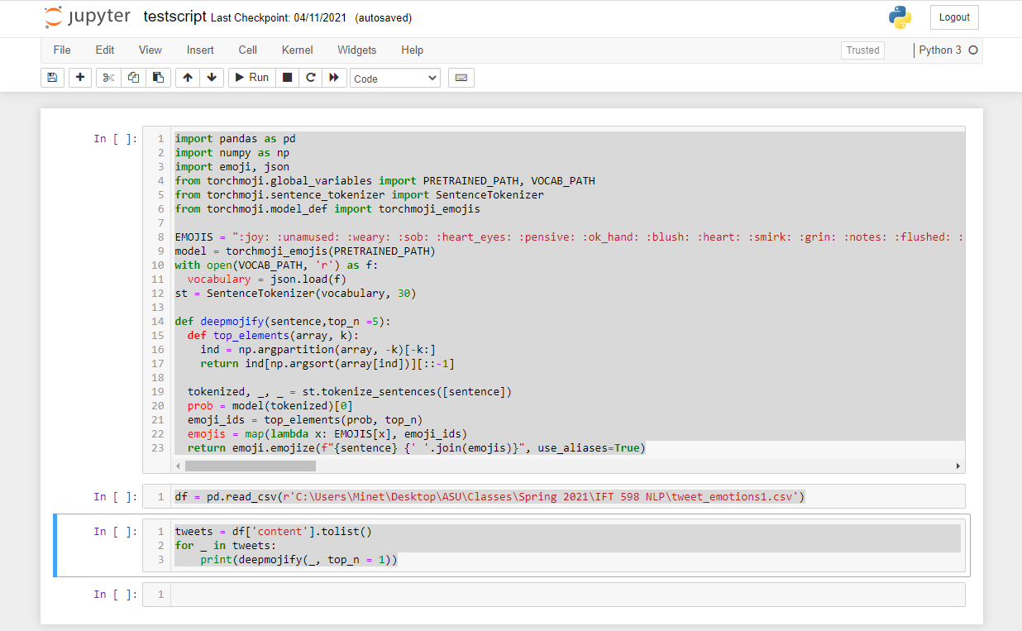

## Appendix 2: TorchMoji output from tweet_emotions.csv

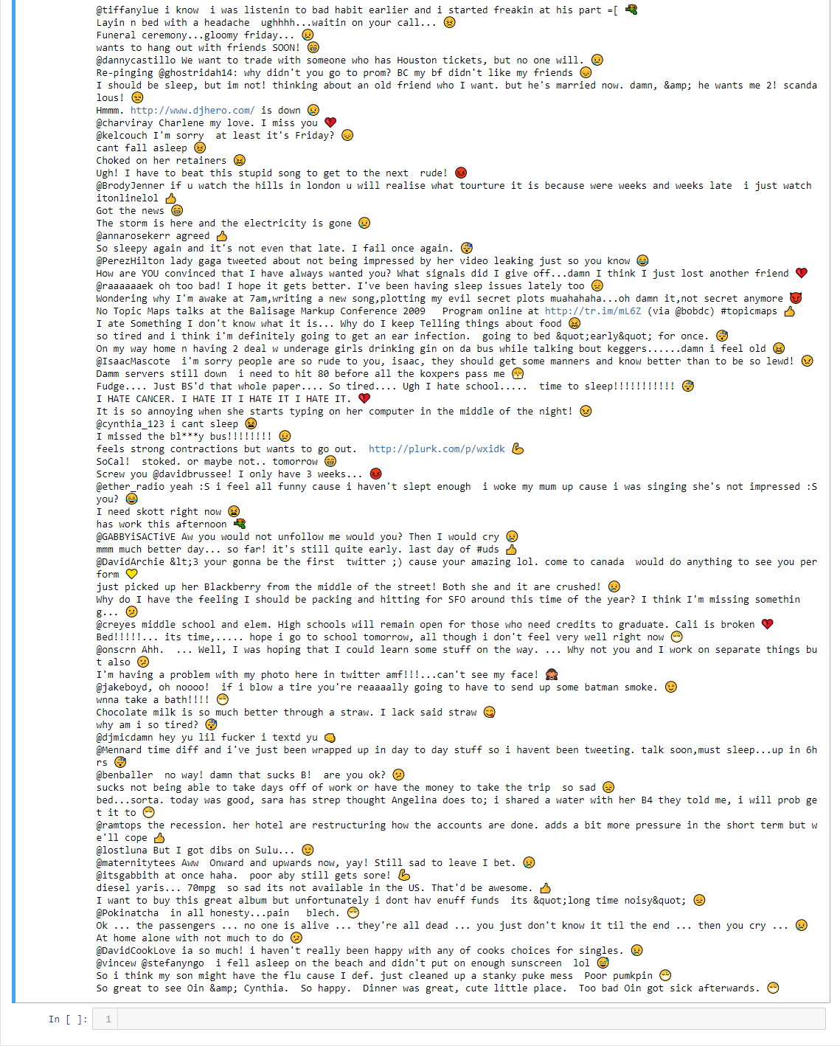

## Appendix 3: Participant data

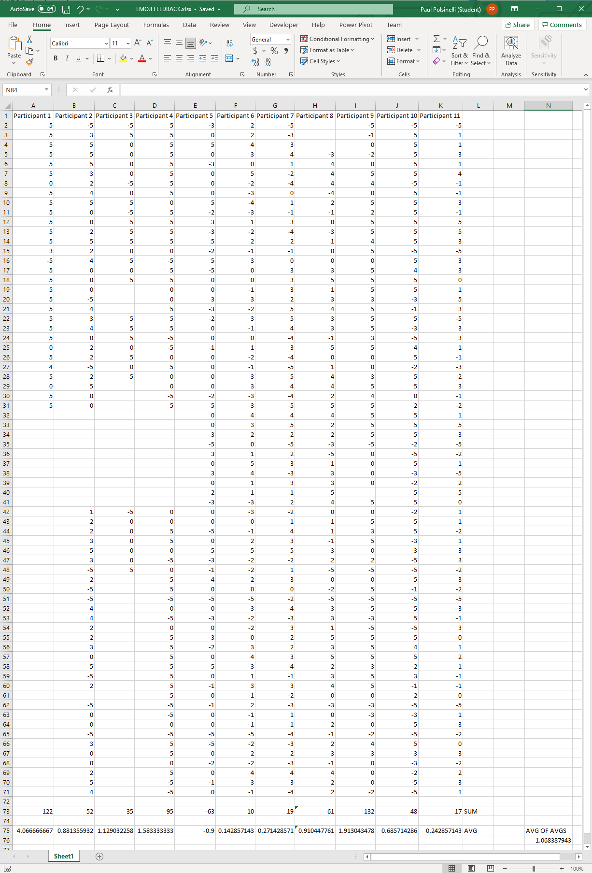

# References

Shiha, M., & Ayvaz, S. (2017). The Effects of Emoji in Sentiment Analysis. *International Journal of Computer Electrical Engineering*, *9*(1), 360–369. https://doi.org/10.17706/ijcee.2017.9.1.360-369

Felbo, B., Mislove, A., Sogaard, A., Rahwan, I., & Lehmann, S. (2017, October). *Using millions of emoji occurrences to learn any-domain representations for detecting sentiment, emotion and sarcasm*. Media Lab, Massachusetts Institute of Technology, College of Computer and Information Science, Northeastern University, Department of Computer Science, University of Copenhagen, DTU Compute, Technical University of Denmark. https://arxiv.org/pdf/1708.00524.pdf

Shetty, B. (2018, November 24). *Natural Language Processing(NLP) for Machine Learning*. Medium. https://towardsdatascience.com/natural-language-processing-nlp-for-machine-learning-d44498845d5b